**JC130 diesel engine**

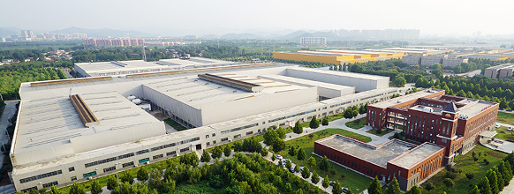

**CNPC Jichai Power Company LimitedCatalog**

1. Product introduction 3

2. Features of JC130 series diesel engine 5

2.1 Product performance characteristics 5

2.2 Features of product structure 6

3. Technical parameters 7

3.1 Technical parameters of marine propulsion 7

3.2 Technical parameters of generator set and engine 8

4. On-site application description 9

4.1 Technical parameters of marine light diesel oil and marine diesel oil in operating mode 9

4.2 Cooling system 10

4.3 Starting system 11

5. Scope of supply and configuration 14

6. JC130 diesel engine structure drawing and interface dimension drawing 16

## 1. Product introduction

The JC130 series diesel engine is a high-power in-line engine independently developed by Jichai, with a power range of 2000kW-3200kW. The fuel can use MGO, MDO and HFO. It can be widely used in marine propulsion, pump power output, marine and land generator sets. IMO TIER II stage.

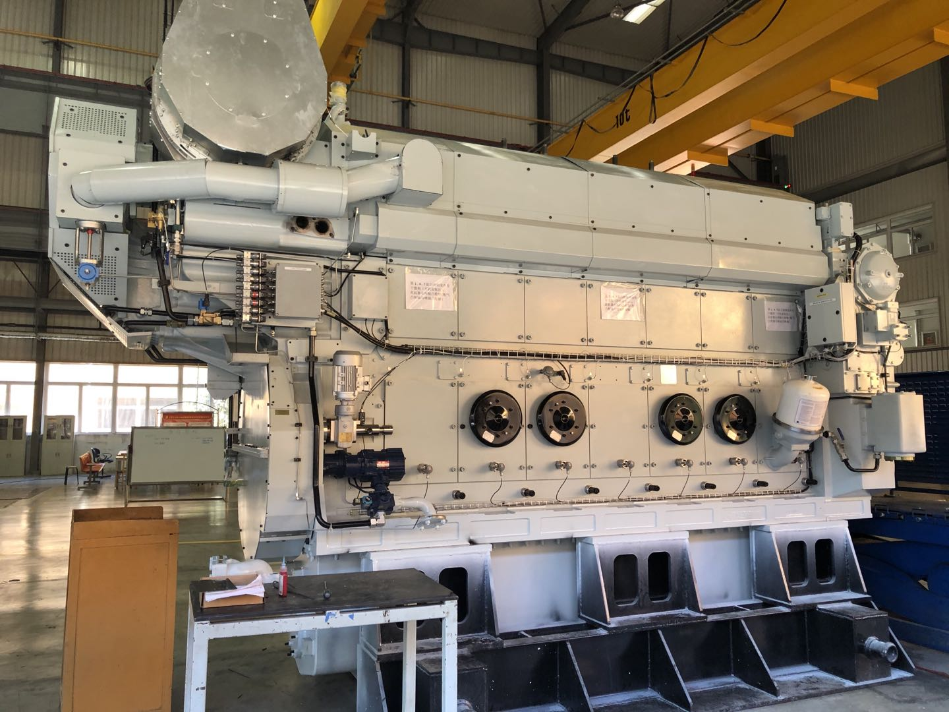

JC130 series diesel engine

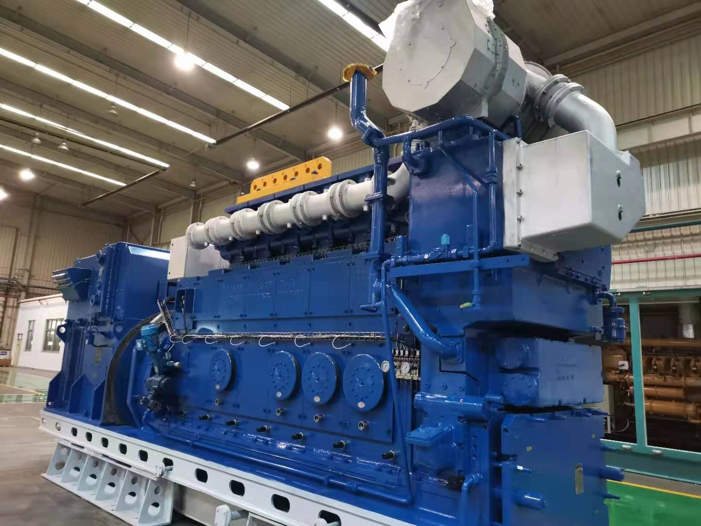

JC130 series diesel engine set

## 2. Features of JC130 series diesel engine

JC130 series diesel engines have the characteristics of high power density, high efficiency, light weight, compact structure, long overhaul period, and humanized design for maintenance.

### 2.1 Product performance characteristics

1. Strong power: The power covers a wide range, which can meet the requirements of 2000kW ~ 3200kW.
2. Good economy: the fuel consumption rate is 185g/kW.h, and the oil consumption rate is less than 0.8 g/kW.h.
3. High reliability: The unique structural design and safety control system of the engine ensure trouble-free operation of the engine and a long overhaul period.
4. Good environmental protection: meet the requirements of the International Maritime Organization (IMO) for the Tier II stage of engine emissions.
5. High safety: meet the requirements of the International Convention for the Safety of Life at Sea (SOLAS).
6. Strong applicability: The fuel has good practicability and can burn heavy oil with a viscosity of up to 700cSt/50℃; according to the operating conditions of the engine, the optimal boost matching scheme is provided, and the heavy oil can be continuously operated under various load conditions. , both have better fuel consumption and emissions.

### 2.2 Features of product structure

1. The body adopts an overall rigid design, with high safety; the cylinder unit is assembled as a whole, which is convenient for loading and unloading;
2. Using advanced turbocharger and two-stage intercooler, the air intake performance is excellent;
3. Simplified front cover, external oil pump and water pump, with simple structure, easy disassembly, convenient maintenance;
4. The lubrication system is designed with an integrated oil adjustment unit, which integrates functions such as oil pressure regulation, temperature regulation, and spare port.

## 3. Technical parameters

### 3.1 Technical parameters of marine propulsion

|  |  |  |  |  |  |
| --- | --- | --- | --- | --- | --- |
| **Type of engin** | **Unit** | **JC130** | **JC150** | **JC170** | **JC190** |
| Power (MDO, MGO) | kW | 2190 | 2555 | 2920 | 3285 |
| Fuel consumption | g/kWh | 191（100%MCR）/186（85%MCR） | | | |
| Power (HFO) | kW | 2040 | 2380 | 2720 | 3060 |
| Fuel consumption | g/kWh | 188（100%MCR）/185（85%MCR） | | | |
| Type |  | Four-stroke, turbocharged, two-stage intercooler | | | |
| Rated speed | r/min | 800 | | | |
| Cylinder arrangement |  | In-line | | | |
| Number of cylinders |  | 6 | 7 | 8 | 9 |
| Length | mm | 5197 | 5642 | 6087 | 6532 |
| Width | mm | 1893 | 1893 | 1893 | 1893 |
| Height | mm | 3715 | 3900 | 3900 | 3900 |
| Displacement |  | 130 | 152 | 174 | 196 |
| Bore | mm | 270 | | | |
| stroke | mm | 380 | | | |
| average piston speed | m/s | 10.1 | | | |
| compression ratio |  | 15.9：1 | | | |
| turn around |  | Clockwise | | | |
| (facing the flywheel end) |  | Air motor starts, starting air pressure is about 10bar | | | |
| Starting method | MPa | 200 | | | |
| Maximum combustion pressure |  | IMO TIER II | | | |

### 3.2 Technical parameters of generator set and engine

|  |  |  |  |  |  |
| --- | --- | --- | --- | --- | --- |
| **Generator set** | | | | | |
| **Model** | **Unit** | **CCFJ-2000** | **CCFJ-2200** | **CCFJ-2500** | **CCFJ-2800** |
| Rated power | kW | 2000 | 2200 | 2500 | 2800 |
| Voltage | V | 11000/6300/660/400 | | | |
| Rated speed | r/min | 750/720 | | | |
| Frequency | Hz | 50/60 | | | |
| Power factor |  | 0.8 | | | |
| cooling method |  | Engine dual temperature forced cooling, generator IC01 air cooling | | | |
| Connection method |  | Elastomeric Coupling | | | |
| Protection class |  | IP23 | | | |
| Excitation method |  | Self-excited constant voltage (AVR) | | | |
| Voltage fluctuation rate |  | ±0.5% | | | |
| Transient Voltage Regulation |  | -15%～+20% | | | |
| Length | mm | 7550 | 8000 | 8660 | 9110 |
| Width | mm | 1893 | 1893 | 1893 | 1893 |
| Height | mm | 3715 | 3900 | 3900 | 3900 |
| Net weight | t | 45 | 51 | 59 | 65 |
| **Engine** | | | | | |
| Engine power | kW | 2080 | 2310 | 2640 | 2970 |
| Cylinder No. |  | 6 | 7 | 8 | 9 |
| Emision |  | IMO TIER II | | | |

## 4. On-site application description

### 4.1 Technical parameters of marine light diesel oil and marine diesel oil in operating mode

|  |  |  |  |  |  |
| --- | --- | --- | --- | --- | --- |
| **Engine cylinder No.** | | 6L | 7L | 8L | 9L |
| Environment temperature | ℃ | 45 | | | |
| Intercooler inlet cooling water temperature | ℃ | 38 | | | |
| Air pressure | bar | 1 | | | |
| Relative humidity | % | 50 | | | |
| Engine output power | kW | 2190 | 2555 | 2920 | 3285 |
| Rotating speed | rpm | 800 | | | |
| **Thermal equilibrium** | | | | | |
| Intercooler (high temperature water) | kW | 716 | 810 | 897 | 979 |
| Intercooler (Low temperature water) | kW | 249 | 282 | 317 | 353 |
| Oil cooling | kW | 242 | 341 | 390 | 438 |
| Water jacket cooling | kW | 326 | 380 | 434 | 489 |
| Engine heat radiation | kW | 54 | 63 | 72 | 81 |
| **Flow** | | | | | |
| High temperature water circulation | m3/h | 58 | | | |
| Low temperature water circulation | m3/h | 58 | | | |
| Lubricating oil | m3/h | 92.5 | 92.5 | 115 | 115 |
| **Air parameters** | | | | | |
| Intake air temperature after intercooling | ℃ | 54 | 56 | 57 | 58 |
| Air flow | m3/h Kg/kWh | 13580  6.79 | 15844  6.79 | 18107  6.79 | 20371  6.79 |
| Intake pressure after intercooling | bar | 4.07 | | | |
| Air volume required for heat dissipation (t2-t1=10℃) | m3/h | 17498 | 20414 | 23330 | 26247 |
| **Exhaust parameters** | | | | | |
| Volume flow (turbocharger outlet temperature | m3/h | 28921 | 33741 | 38562 | 43382 |
| Mass Flow | t/h | 15.3 | 17.9 | 20.4 | 23.0 |
| turbine outlet temperature | ℃ | 385 | | | |
| Heat content | kW | 896 | 1045 | 1194 | 1343 |
| Allowable back pressure | mbar | ＜30 | | | |
| **Pump (external pump)** | | | | | |
| Diesel pump (fuel inlet pressure 3.5bar) | m3/h | 2.35 | | | |
| Oil pump | m3/h | 60 | 60 | 75 | 75 |
| High temperature water cooling water pump (2.5bar) | m3/h | 58 | | | |
| Low temperature water cooling water pump (2.5bar) | m3/h | 58 | | | |
| **Starting air parameters** | | | | | |
| Air consumption | Nm3 | 2.9 | 3.3 | 3.8 | 4.3 |

### 4.2 Cooling system

The low temperature cooling water system consists of the following parts: low temperature cooling water pump, secondary intercooler, lubricating oil cooler, low temperature water cooler, control valve, expansion tank, etc. The expansion tank must be installed above the highest point of the cryogenic cooling water system.

The high-temperature cooling water system consists of the following parts: a first-stage intercooler, a high-temperature cooling water preheater, a high-temperature cooling water pump, and a high-temperature temperature control valve. The outlet temperature of the engine cylinder cooling water needs to be adjusted to 77-86°C.

For the high temperature cooling water system, each engine needs to be used for a separate high temperature cooling water pump, expansion tank, etc. The expansion tank is used to compensate for the system volume change and water loss due to leakage, and the expansion tank must be installed above the highest point of the high-temperature cooling water system.

The piping in the system should be as short as possible in order to reduce the number of system failures, especially the piping between the three-way mixing valve and the engine inlet (cylinder cooling), which is critical for control.

HT: The outlet water temperature of the engine is controlled at 77-86°C, and the preheating is 60-90°C before starting. 15 minutes of post-cooling is required after the engine is stopped. LT: The air temperature after intermediate cooling should be controlled at 30-40℃.

In a high temperature environment, the parallel operation of the oil heat exchanger and the low temperature heat exchanger should be considered. It is recommended to have a maintenance water tank for draining and reusing water during maintenance such as the cylinder head.

### 4.3 Starting system

The compressed air system of the engine consists of a starting system, a starting control system and a safety system. Furthermore, the system supplies air to the injection booster system and the brake cylinders of each fuel injection pump. The air in the starting air bottle (30bar) is reduced to 10bar by the decompression station and then supplied to the engine. The decompression station should be located as close as possible to the priming air bottle. The engine is started by an on-board air motor, which is a turbo motor with a gearbox, safety clutch and a pinion drive shaft. The starting system is fitted with a main starting valve.

The gas starting sequence is as follows:

1. When the priming valve is open, air is supplied to the drive shaft housing of the air motor.
2. The air pushes the piston inside the motor so that the drive pinion extends and meshes with the ring gear on the flywheel of the engine.
3. When the pinion gears are fully engaged, control the inflow of air, open the main start valve, and enter the air motor at the main start valve to run the engine.
4. When the speed exceeds about 158 rpm, the engine starts to ignite, the starter valve is closed, and the starter motor is disengaged.

4.4 Fuel system

Diesel from the storage tank, after being processed by the diesel separator and diesel separator, enters the fuel primary filter, and the filtered clean diesel is pressurized into the fuel filter through two fuel transfer pumps (one for use and one for standby). This filter is a double device. , to ensure non-stop cleaning of the filter. Filtered fuel enters the engine from the fuel injection pump; the engine fuel injection pump returns fuel into the fuel tank. The system is also equipped with a leaked oil collection tank, which can collect leaked oil and save costs.

4.5 Lubrication system

The JC130 series engine is equipped with an independent lubrication system. Wet oil pan is adopted, and the lubrication system is composed of external pre-supply oil pump, backup pump and other equipment together with machine-operated lubricating oil pump, automatic filter, centrifugal filter and oil cooler. The internal lubrication of the engine and supercharger is forced lubrication. In addition, the cylinder liners and valve seats are also forcibly lubricated.

The lubricating oil system includes: external accessories: pre-supply oil pump, oil tank.

Internal parts: pressure regulating valve, one-way valve, automatic oil filter, centrifugal filter, temperature regulating valve, oil cooler, oil pump and lubrication pipeline.

When the engine is working, pre-lubrication should be carried out before starting, and post-lubrication should be carried out after stopping, especially after emergency stop, and lubricating oil should be preheated in low temperature environment.

Pre-lubricate for 5 minutes before starting; lubricate for 15 minutes after stopping

The pre-oil pump is also used for supercharger lubrication after parking, and the duration of post-lubrication is 15 minutes.

## 5. Scope of supply and configuration

|  |  |  |  |
| --- | --- | --- | --- |
| **Item** | **Description** | **Standard** | **Option** |
| 1 | Flywheel, ring gear with reel |  |  |
| 2 | Electric turning mechanism and safety interlock device |  |  |
| 3 | Crankcase explosion-proof door |  |  |
| 4 | Main bearing temperature sensor |  |  |
| 5 | Governor |  |  |
| 6 | Diesel engine monitoring and security system |  |  |
| 7 | Fuel double filter |  |  |
| 8 | Fuel return cooler |  |  |
| 9 | Fuel return back pressure valve |  |  |
| 10 | Fuel transfer pump |  |  |
| 11 | Plate type oil cooler |  |  |
| 12 | Oil temperature control valve |  |  |
| 13 | Oil pump |  |  |
| 14 | Electric backup oil pump |  |  |
| 15 | Automatic backwash filter for lubricating oil |  |  |
| 16 | Centrifugal filter |  |  |
| 17 | High temperature water pump |  |  |
| 18 | Low temperature water pump |  |  |
| 19 | High temperature water temperature control valve |  |  |
| 20 | High temperature water temperature control valve |  |  |
| 21 | Electric high temperature water pump |  |  |
| 22 | Electric low temperature water pump |  |  |
| 23 | Cooling water preheating unit |  |  |
| 24 | High temperature water plate cooler |  |  |
| 25 | Low temperature water plate cooler |  |  |
| 26 | Air bottle |  |  |
| 27 | Air pressure reducing valve group with safety valve and filter |  |  |
| 28 | Air starter motor |  |  |
| 29 | Supercharger |  |  |
| 30 | Two-stage intercooler |  |  |
| 31 | Supercharger Random Tool |  |  |
| 32 | Turbocharger random spare parts |  |  |
| 33 | Exhaust temperature sensor |  |  |
| 34 | Turbocharger outlet expansion joint |  |  |
| 35 | Muffler with spark extinguishing function |  |  |

## 6. JC130 diesel engine structure drawing and interface dimension drawing

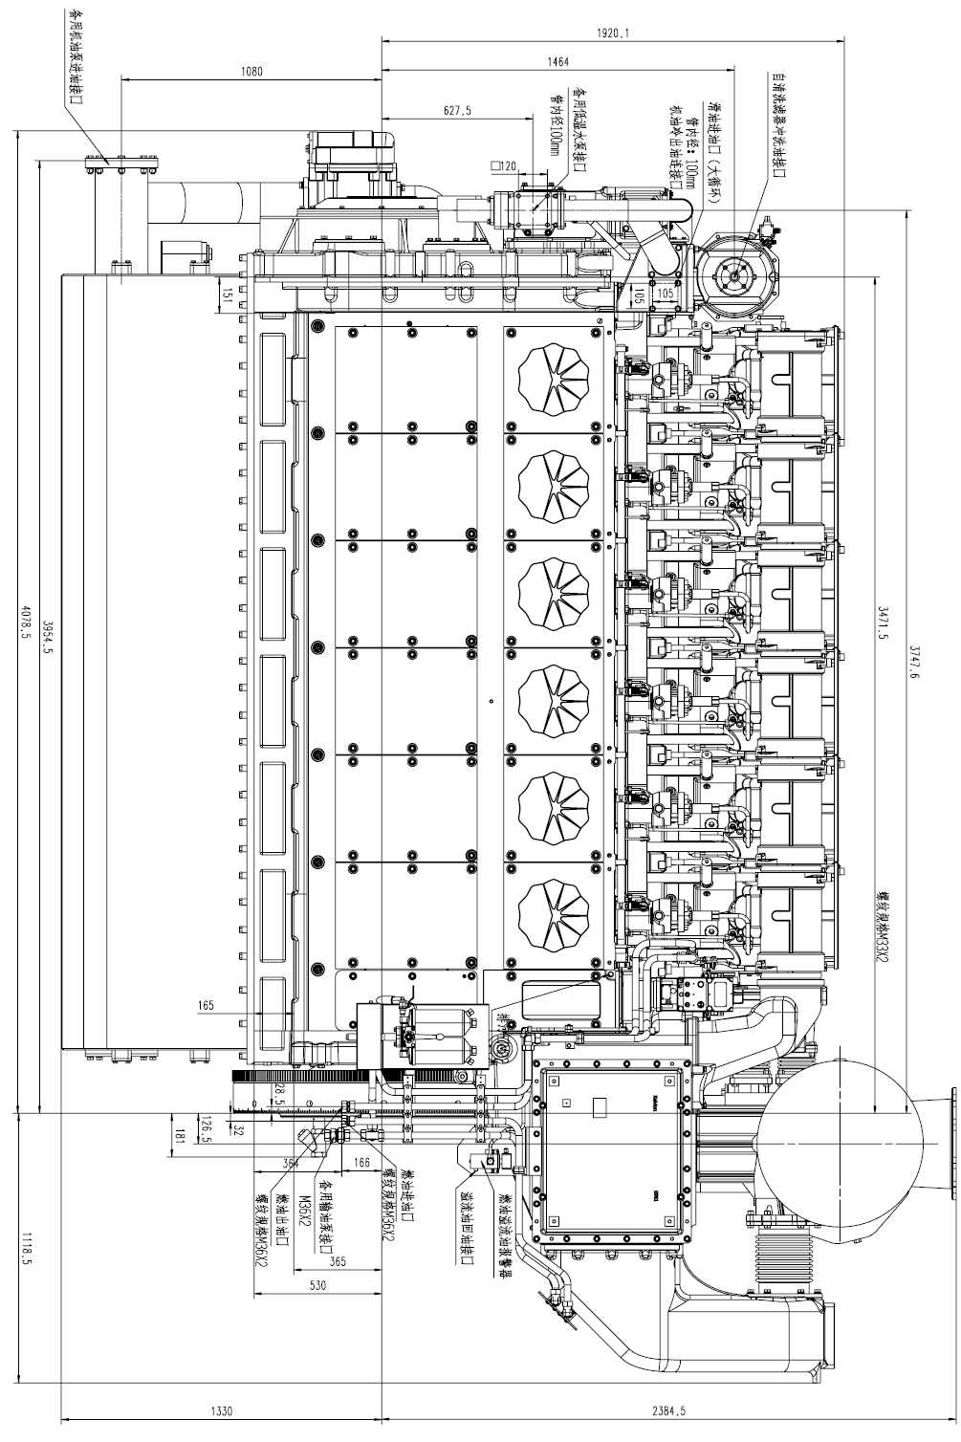

JC130 side view

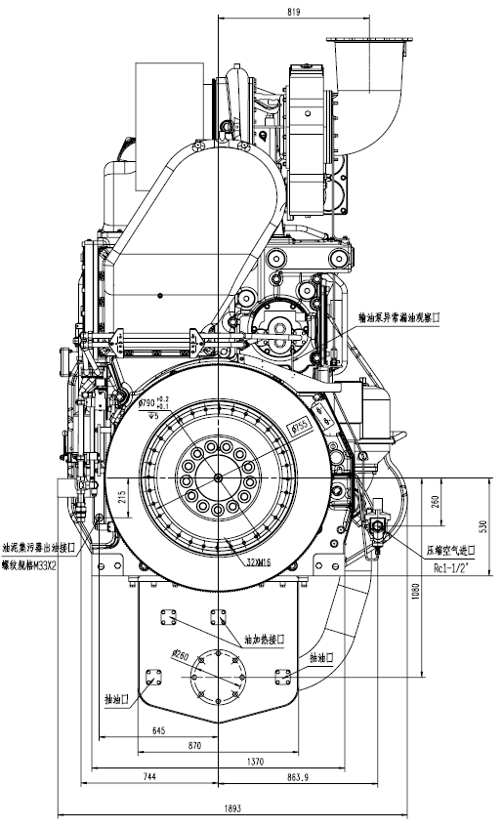

JC130 Flywheel Side View

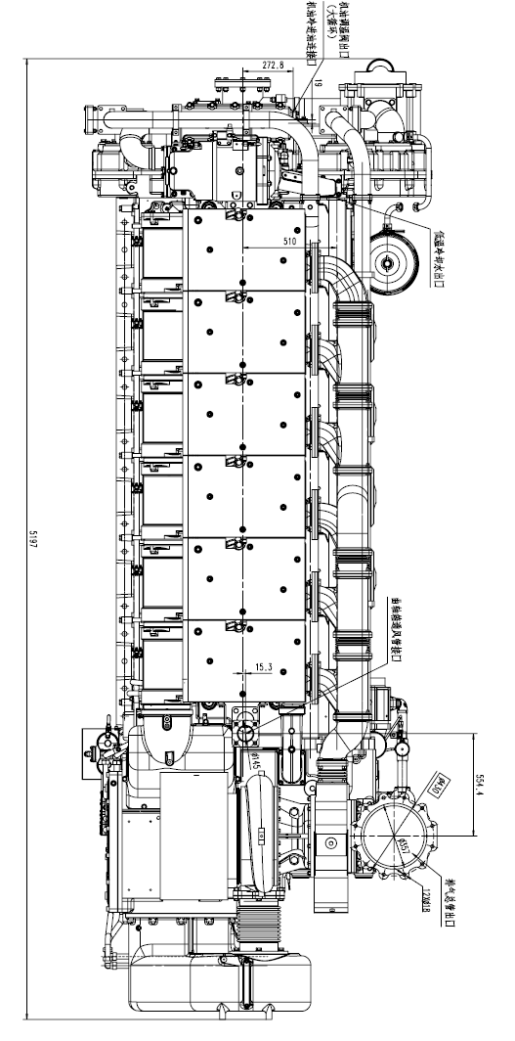

Top view of JC130

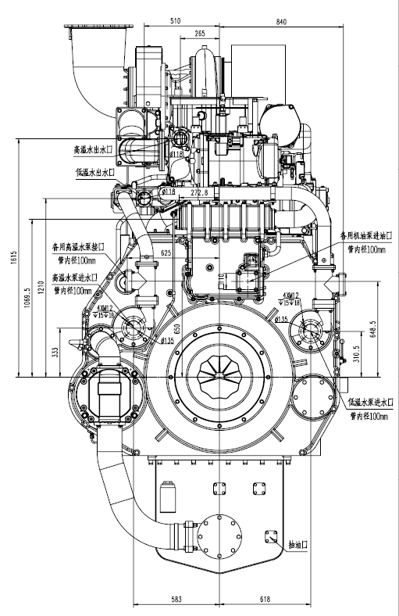

End view of JC130 shock absorber

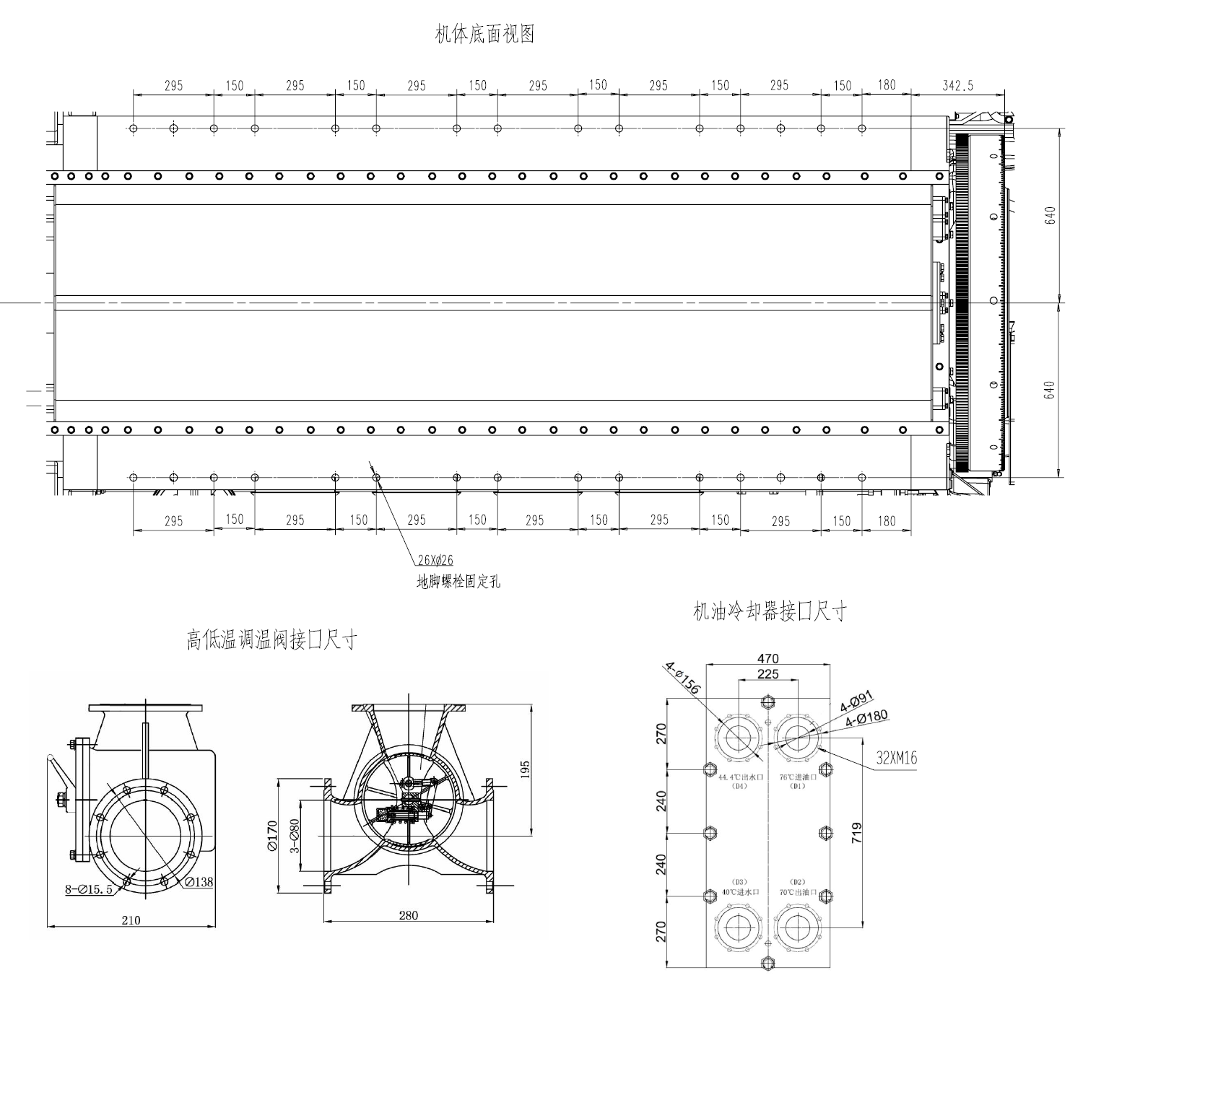

Bottom view of JC130 body and size of oil and water interface